**Save The Countryside**



**Response to All Party Parliamentary Group Greenbelt**

**Contact: Helen Wells** [**hwells@mdlz.com**](mailto:hwells@mdlz.com)

**Tel 07770 986078** [**www.savethecountryside.org.uk**](http://www.savethecountryside.org.uk)

**To:** [**appggreenbelt@gmail.com**](mailto:appggreenbelt@gmail.com) **Room 20, Norman Shaw North, House of Commons, SW1A 0AA.**

**Introduction**

Save The Countryside is an organisation made up of many residents in Cheltenham and adjoining areas of Tewkesbury Borough. Working since 2006, we all share the determination to protect the precious Greenbelt land around the town - and nationwide - now under threat from massive developments.

The group has responded to multiple consultations with regards to the Joint Core Strategy (JCS) of Cheltenham, Tewkesbury and Gloucester, local plans, the draft National Planning Policy Framework, the South West Regional Spatial Strategy and other relevant planning consultations and applications.   
We have valued previous opportunities for direct consultation with Government Ministers and local Council members and would welcome such involvement in the process going forward.

The Joint Core Strategy proposes development of 33000 new homes over a 20 year period with 15000 being built on Greenbelt land.

As the majority of its members live in Swindon Village, Uckington and Elmstone Hardwicke, Save The Countryside has a particular concern with the proposed North West Cheltenham Urban Extension in the Joint Core Strategy Draft for Consultation, October 2013, this is greenbelt land currently used for food production.

While we recognise that a reasonable level of growth should be possible in Cheltenham and the surrounding area, we believe that urban extensions and incursions into the Green Belt are unnecessary and in the specific case of Swindon Village, have grave doubts about the suitability of this green belt land as a development site.

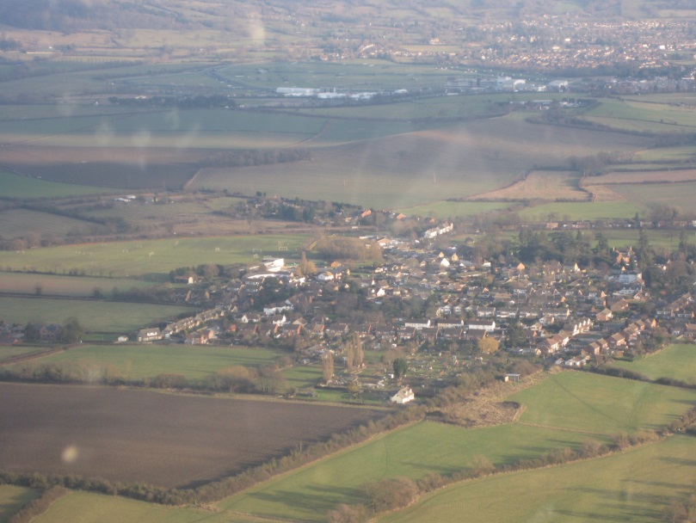

Swindon village an area with 1450 residents under threat of 4829 new homes on the surrounding Green Belt land if the NW Urban Extension is implemented

Save the Countryside is delighted to respond to the specific questions and will be willing to work with the group on the evidence report and oral sessions in 2014.

Attached also is the latest response to the Joint Core Strategy preferred option consultation of Cheltenham Tewkesbury and Gloucester.

**Response to Questions from All Party Parliamentary Group**

1. **How can it be made clearer to the media the important distinction between ‘greenfield’ land and ‘greenbelt’ land- with the importance of greenbelt being highlighted as separate from greenfield.**

The 5 core reasons for Greenbelt as stated within the NPPF can be used to clarify the difference between Greenbelt and Greenfield land.

Greenbelt is specifically maintained for the following reasons:

* prevents a town sprawling,
* prevents it merging with other towns
* safeguards the countryside from encroachment,
* preserves the setting of a town centre and
* encourages town centre regeneration

1. **What has been the effect of the abolition of Regional Spatial Strategies and the introduction of the National Planning Policy Framework in the context of the preservation of greenbelt land?**

With regards to Cheltenham, Save the Countryside were delighted that the controversial Regional Spatial Strategy (RSS) was abolished. Its dictated specific sites for development with huge focus on green belt development, with little regard to local actual need or existing residents opinions or needs was objectionable.

Since then, the 3 neighbouring towns Cheltenham Tewkesbury and Gloucester needed to develop long term plans for the area known as the Joint Core Strategy (JCS). However In this area, despite much discussion and evidence to the contrary the JCS has come up with an almost identical plan for development in the area as the RSS had, with a huge focus on development in the Greenbelt over regeneration and brownfield development.

1. **Which local councils are taking their obligations on greenbelt preservation seriously and which local councils are placing greenbelt land under threat?**

In this area none of our local councils are taking their obligations seriously.

In council chamber meetings despite huge volumes of evidence to support the argument that green belt development is misguided and that the required housing volumes were erroneous, the 3 Councils of Cheltenham, Tewkesbury and Gloucester still decided to pursue the plan for massive greenbelt development.

Out of the proposed total housing need of 33000 homes, they proposed 15000 to go on Greenbelt land despite the fact that there is room to build 18000 on brownfield sites. The purple areas in the chart below shows the land proposed to be removed from the greenbelt and developed as urban extensions before brownfield sites are developed.  This is an exaggeration of the housing need. Ignoring evidence from ONS/DCLG



There is every indication that the JCS team for Cheltenham, Gloucester and Tewkesbury has made a decision to maximise the estimate of future housing need purely so that they can permit building in the green belt.

The JCS team calculate that a 24.3% increase in housing will be needed over the next 20 years.

There are a number of reasons for considering this to be a considerable over-estimate.

1. In the ten year period between the 2001 and 2011 censuses the population in the JCS area increased by 5.7%. This equates to a twenty year increase of 11.4%. This is hardly indicative of a need for a 24.3% increase in housing need over the next 20 years.
2. Bath can be considered as comparable to Cheltenham. Their core strategy, even including some additional housing required by the inspectorate after the first examination, looks to a 16.7% increase in housing over 20 years. If a similar16.7% increase were applied to the JCS, the housing requirement would reduce about from 33,200 houses to under 23,000.
3. It is possible to identify locations outside the green belt which can accommodate this quantity of housing. It is only the inflated growth figure that necessitates building in the green belt.
4. The JCS Housing Target numbers were based upon ONS Interim Projections.   
   The ONS itself has stated that these are not the appropriate figures for this application.   
   The ONS considers that the revalidated projections published in 2012 are more appropriate. Using these figures brings the population projection down by about 24,000 persons and the housing projection down by over 10,000 houses.

This certainly gives the impression that a conscious effort has been made to provide figures that force a breach in the greenbelt. The JCS team have not indicated why they have used such an inflated level of growth.

Therefore we can only surmise that it is because the higher level of administration within the three councils have decided that they wish to press for expansion at all costs under pressure from developers and local non accountable agencies which have charged themselves with pressing for local economic expansion whether or not it is in fact either feasible of desirable.

1. **What new policy ideas should be considered to increase greenbelt protection?**

All local authorities should use the same ONS figures.

There should be a much stronger policy to develop brown field land before green belt such as the policy by the previous Labour Government.

Abolish or reduce the new homes bonus for houses built on green belt land.

Any building on the green belt must be compensated by creating an equivalent area of new green belt.

Stop charging VAT for redevelopment. Protection of Grades 1 to 3A agricultural land.

The existing protections for green belt land are good (paragraph 89 in NPPF is fine); the problem is that councils can under existing policy remove land from the green belt.

We believe the policy in paragraph 84 in the NPPF should be changed to allow development in the green belt only after all brown field land has been redeveloped.

1. **Should brownfield land in greenbelt areas have the same protection as Greenfield land in greenbelt areas?**

                We are content with the existing policy for brownfield land within the green belt.

1. **How can we increase local community engagement in protecting the greenbelt?**

We should encourage local residents’ access into the countryside and the provision of nature conservation areas.

Councils should be obliged to formally take into account local opinion.

MPs should publicise the purpose of the green belt.

1. **How do we balance the need to sustain the greenbelt with the need for sustainable communities?**

Building on brown field land in the town is more sustainable than building on the edge of a town in the green belt (i.e. good infrastructure such as transport links and shopping and recreational facilities). We should make more use of disused housing in towns and providing accommodation above shops. There should be greater incentives to build on brown field land.

1. **Should certain areas of greenbelt land be given higher protection than other areas?**

                All green belt is of equal value and needs to be preserved.

1. **What should the greenbelt look like for the twenty first century?**

It should continue the same as today as it is fulfilling the purposes intended as when was be established. We support productive agricultural land and recognise the recreational vale of the green belt next to urban areas.